Task 2 – Research Notes and Writing Plan
Student Name: Oleh Melnychuk (L00194760)
Friday, 28 November 2025
Proposed Title of Research Essay
The Need for Humans in Game Development.
Topic Choice
I chose this topic because I want to explore important questions for me about the core interactions between players and developers as an author in games. And how the strength of this interaction is diminished by increasing the technological gap between the developer and the final product, as well as the player.
I want to emphasise the importance of having a human author as well as a developer to bring a deep understanding of mechanics and the concept behind creating each element of the player's experience.
Motivation
I’m interested in going deeply into understanding what a game is and what the future of game development is. Will humans be replaced by technologies in the field of game development? What makes games enjoyable? Will people enjoy games purely made without humans? If yes, does this mean the death of Game Development? What is the difference between drugs and games if they will bring endless joy without reasoning, deeply thought-out ideas, and lessons? These questions inspire me to research.
In our rapidly changing society, we can’t fully see the picture of the near future, and that is exactly what motivates me towards this research. I’m interested in a deep acknowledge of the reasons why people like and play games. And how abstracting from the development cycle will affect the quality and flexibility of games. Would this step completely diminish developers' capacity to create enjoyable games?
Research Question
Is a human required in the development cycle of enjoyable games?
Thesis Statement
I believe that human is required in a development cycle of enjoyable games because:
- Every game has some form of feelings that the developer wanted the player to feel and experience. I believe that the beauty of this experience is the motivation of the developer behind each fragment of the game. It might be a small detail like covers of books on a shelf, or as a purely thoughtful gameplay mechanic, exactly configured to enhance the whole experience. If we trust some form of tool to make all of these fragments, we will just lose the deep connection and beauty of the entire game.
- Most likely, overuse of generative tools will lead to diminishing knowledge of developers. In the long run, this could be followed by the inability to apply any changes to the final product. This is the same concept as asking a language model to write an essay in a language that you don’t know. You might get some results, but developers will be unable to apply any changes to the final essay or code, art, or any type of content.
- Any game was made through a large number of iterations. Most game engines are built to run a game in its current state immediately, which allows developers to experience changes in real time, merging small portions of prototyping and testing. The same can be applied to the content made for games. The pattern of game creation was made for fast prototyping. If we separate and automate development, we will lose control over iterations, as well as making the final product fun and enjoyable.
Caveats, Counter-Arguments and Other Issues
I think the biggest problem and counter-argument is the business part of the whole industry. It is obviously cheaper to use technology to replace people than to pay a salary. Most companies want to decrease their costs as much as possible, which leads to a lot of frustration among workers and players.

References and Bibliography
Bordas, A. et al. (2024) “What is generative in generative artificial intelligence? A design-based perspective,” Research in Engineering Design, 35(4), pp. 427–443. Available at: https://doi.org/10.1007/s00163-024-00441-x.
“Entertainment” (2025) Wikipedia. Available at: https://en.wikipedia.org/w/index.php?title=Entertainment&oldid=1319397313 (Accessed: November 6, 2025).
Fullerton, T., Swain, C. and Hoffman, S. (2004) Game Design Workshop: Designing, Prototyping, & Playtesting Games. CRC Press.
“Game” (2025) Wikipedia. Available at: https://en.wikipedia.org/w/index.php?title=Game&oldid=1320742539 (Accessed: November 6, 2025).
Koster, R. (2014) A theory of fun for game design. 2nd edition. Sebastopol, CA: O’Reilly.
Miller, G.A. (1956) “The magical number seven, plus or minus two: Some limits on our capacity for processing information,” Psychological Review, 63(2), pp. 81–97. Available at: https://doi.org/10.1037/h0043158.
Mirza-Babaei, P., Moosajee, N. and Drenikow, B. (2016) “Playtesting for indie studios,” in Proceedings of the 20th International Academic Mindtrek Conference. AcademicMindtrek’16: Academic Mindtrek Conference 2016, Tampere Finland: ACM, pp. 366–374. Available at: https://doi.org/10.1145/2994310.2994364.
Schell, J. (2008) The art of game design : a book of lenses / by Jesse Schell. Elsevier/Morgan Kaufmann.
Technologies, U. (no date) Unity - Manual: Unity 6.2 User Manual. Available at: https://docs.unity3d.com/6000.2/Documentation/Manual/UnityManual.html (Accessed: November 6, 2025).
Unity Learn (no date) Unity Learn. Available at: https://learn.unity.com (Accessed: November 6, 2025).
Ward, M. (1995) “A definition of abstraction,” Journal of Software Maintenance: Research and Practice, 7(6), pp. 443–450. Available at: https://doi.org/10.1002/smr.4360070606.
Note on Sources:
For all my main sources, I was trying to choose the biggest and most well-known people in the Industry of Game Design.
For my secondary sources, I was searching for peer-reviewed and most-referenced works.
For my initial research, I used more abstract and easier-to-understand sources, such as websites, Wikipedia pages.
(“Entertainment,” 2025; “Game,” 2025; Unity Learn, no date; Technologies, no date)

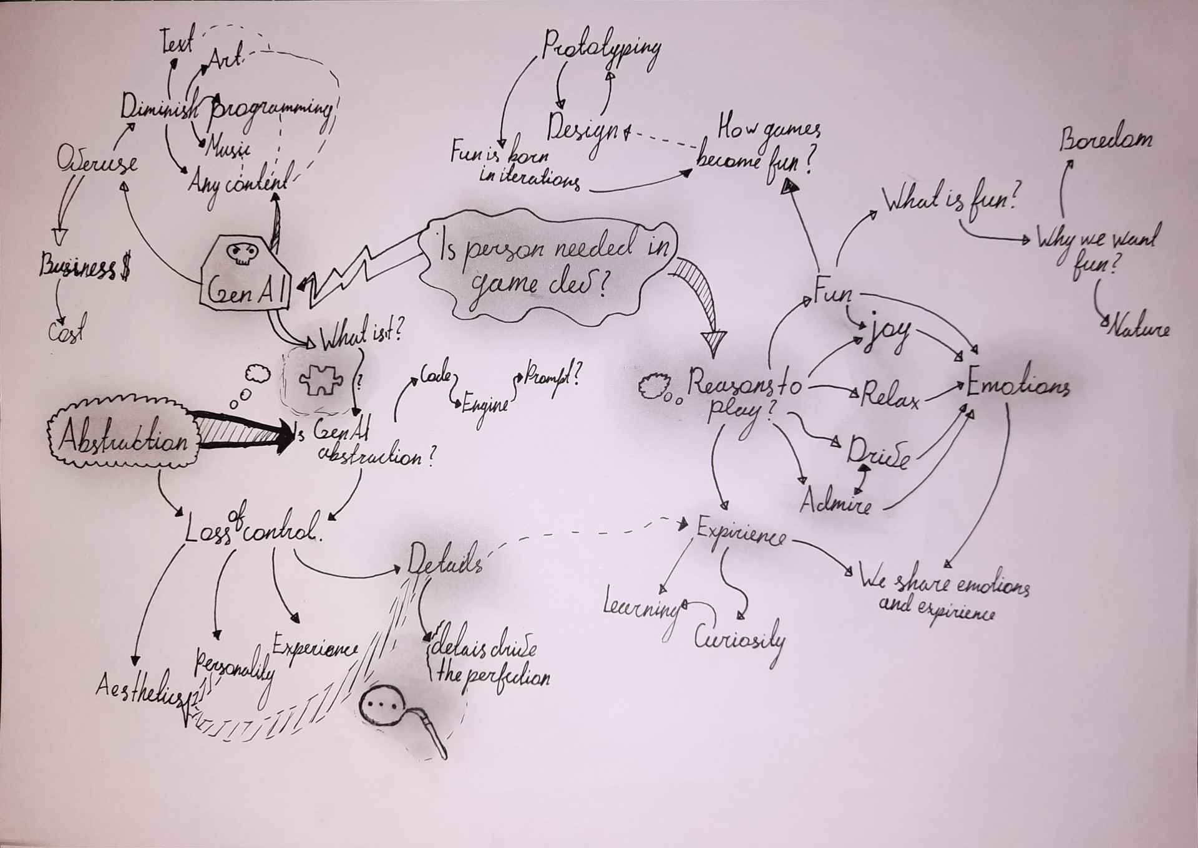

Research Program
Experience | Generative | Iterations | Joy
What is a game? | What is Generative AI? | What is prototyping? | What is the nature of fun?
What is a play? | Is GenAI a level of abstraction? | What is the advantage of prototyping? | What is boredom?
Why do people play games? | What is abstraction? | What is playtesting? | What is the reason for the game to be boring?
Do games change players? | Does abstraction mean loss of control over details? | What is the goal of playtesting? | Why do we need fun as a species?
How do games teach us? | Does GenAI as an abstraction level mean loss of control over details? |  | How does fun become part of the game?

What is a game? | The word “game” has a lot of different definitions, which have a hard time explain what we usually name as a game.  It is rare to see fun as part of these definitions.  Some game designers offer their own definition of this word, but every single one differs from the others.  Raph Koster himself gives it an interesting definition as “Games are just exceptionally tasty patterns to eat up”.  (Koster, 2014)  Jesse Schell starts his description of a game with a phrase  “A game is something you play.” This is a self-explanatory definition, and it is hard to debate about it. So to answer this question, we need to understand what “play” is.  (Schell, 2008)
What is a play? | “Play is whatever is done spontaneously and for its own sake.” – George Santayana  We can argue about the spontaneity of games, which is not always true, but an important part of a play is that it's done for its own sake. We can’t name something play if we are forced to do it without our own interest, or in other words sake. Even work in some examples can easily become play if we have our own personal goal, interest or sake for doing it. The more we are forced to do certain things, the more it feels like work, rather than play. And backwards, the more it was your own choice to do a certain thing, the more it feels like play. “Whoever must play cannot play”.  The final is his own definition, which Jesse Schell suggests as his own vision of play as action in which the game is born:  “Play is manipulation that indulges curiosity.” – Jesse Schell  This definition tries to interpret our inner motivation and curiosity to find answers to simple questions like:  - What will happen after this level?  - Can I beat my last record?  - Can we defeat this enemy?  - What happens when I press this button?  (Schell, 2008)
As the answer to the previous question. Most games should have the essential key aspects to be considered a game.
- Games are entered wilfully.
- Games have goals.
- Games have conflict.
- Games have rules.
- Games can be won and lost.
- Games are interactive.
- Games have challenges.
- Games can create their own internal value.
- Games engage players.
- Games are closed, formal systems.
(Schell, 2008)

What is the nature of fun? | Word fun comes from “fool” or from “pleasure” in different interpretations. The main meaning is “a source of enjoyment”, not only as physical or mental joy, but also as chemical manipulation.  Fun is the release of endorphins.  It is a lot of different sensations based on cocktails of chemicals.  The pleasurable chills from listening to powerful music are caused by the same chemicals that the person gets from having cocaine, an orgasm or chocolate.  Our brain is technically on drugs all the time.  (Koster, 2014) pp.40
What is boredom? | Boredom is the brain's reaction to the inability to learn. It is a mechanism that pushes us into doing something that can lead to new information or simply fun.  Boredom occurs when we lack cognitive challenges.  The whole idea around learning desire doesn’t mean that it must be a completely new experience, just new data is enough for the brain to start having fun.  Sometimes we experience “sensory overload” when the brain receives overwhelming and complex data. This state is the opposite of “sensory deprivation”.  For the game to stay fun, it needs to balance between deprivation and overload.  We get bored once we master a skill or realise that we can’t get better. (Koster, 2014) pp.42
What is the reason for the game to be boring? | The main reasons for games to be boring could be:  - The game doesn’t show any challenge quickly enough.  - Player gets overwhelmed with depth, which he thinks is out of his interest.  - Player doesn’t catch the patterns and sees the game as noise.  - Player finds difficulty ramps too slow, which makes the game look trivial.  - Player finds difficulty ramps too quickly, which makes the game feel noisy and/or hard.  - Player masters the whole pattern and doesn’t see any more challenges. In other words, he beats the game.  It is important to note that not all of these reasons of boredom will leave the same expression on the player after getting bored. A good game is it is “One that teaches everything it has to offer before the player stops playing”.  (Koster, 2014) pp.44
Conclusion:
It is important to balance the game experience way that the player will be able to catch the learning rhythm of the whole difficulty curve without losing their interest. It is a really neat process of balancing and revealing new content, mechanics or any sort of challenges which the player will encounter. Developers need to keep a deep understanding of the mechanics to achieve the best results.
I think this is exactly what could be lost by using tools to generate code for mechanics. You might get a popular solution for a certain problem, but it will disconnect the developer from comprehending the exact logic behind certain solution.

 | The beauty of games is that they teach us something we most likely never could experience in the way that they show it to us.
Why do we need fun as a species? | Fun is an important survival mechanism which pushes the human species to adapt, learn and master new skills or tasks. As a reward, fun is a moment of pleasure about an accomplished scenario.  “Fun is just another word for learning”
 | As an argument, we can see so many people saying that learning is boring, but most likely the problem is in the method of receiving information. Usually, it is way easier to learn in a playful or fun environment. Exactly, this makes games good teachers, but we need to remember that not all games have good lessons.
How does fun become part of games? | A big part of the fun in games is based on learning or mastering a certain skill set.  It is still important to remember that we can be easily overwhelmed or underwhelmed by the challenge that we are facing. It is not just a simple answer, “learning makes games fun”. We need to take into account a lot of small variables to make people enjoy, struggle, learn and master without getting the player bored.  (Koster, 2014)
Why do people play games? | I believe that this is a straightforward question, considering all the hard work was already done by some giants in the craft of Game Design and Psychology.  Based on the works of (Schell, 2008; Koster, 2014), I believe that people seek fun, joy and emotions in a way that allows them to experience all of this without much friction easily. It is easier and much safer to play a game about a submarine expedition than to actually be in one in real life. Of course, experience will be completely different, but it will achieve the goal of fulfilling the player with new experience, mechanics, story and struggles that might be completely new for a player. We have our internal infinite source of curiosity, and this urge for new data is pushing us to get fun and games just happens to be the most efficient way of fulfilling these urges of our brain.

Do games change players? | It is a controversial topic. Some people can say that games have a dangerous effect on people's brains, causing violence and addiction, at the same time as other people completely deny any long-term effects from games. At the same time, we see movement of games which trying to teach people or just show an important thing that most of us are missing.  It is a lot of different ways games could actually help a player in completely different ways. Some of them could lead to gaining new knowledge and experience, changing the worldview of the player. Some of them could help emotionally get through hard personal issues, they can help to vent anger and frustration, cheer the player up, build confidence or simply relax.  Games can help people connect, acting as some sort of social bridge, building mutual interest among speakers or just by making communication easier with each other by solving problems together, which will lead to shared memories after a game ends.  (Schell, 2008)
How do games teach us? | A big part of learning dominance of games is the example of Miller’s pyramid of learning. This model mentions learning as steps towards full acknowledgement, it includes steps such as: “Knows”, “Knows how”, “Shows”, “Does”. Games mostly focus on the last step: “Does”. Most of the experience and learning in games happens in practical examples, where we rarely have explanations, but we try and practice certain things without even though. This action achieves the best results in learning, even sometimes by skipping the explanation and knowledge part.  (Schell, 2008)
Games can affect our lives, but the thing that actually transforms our lives is experience, and this is exactly what the whole goal of every game is: to share, create or imagine experience. Exactly, experience changes our way of thinking and the way we see the world, from simple communication patterns that we use on a day-to-day basis, up to deep thoughts and the way we think about simple things. Every aspect of our lives is shaped by our experiences in the past. Games are just perfect for making people have this experience with minimal friction. So every developer should question themselves at one point, “How can my game change players for the better/worse?”
(Schell, 2008)
Conclusion:
Games are part of our lives, and every moment in it was an experience; we experience new music, stories, films and events in life the same way we experience games, but other media don’t usually include us in the process of this experience. Each game can give a completely different experience to different people or even ourselves at different times. A story-heavy game can be completely skipped as nonsense by a child, but it can change their life forever after replaying it in adulthood. It is a giant responsibility of developers to determine what their game will bring to our world.

What is prototyping? | The word “prototyping” means creating a rough example of the final product to have the opportunity to test how it works beforehand.  This allows designers to make great designs through a repetitive process of testing and adjusting the project without a giant loss of development progress if some mechanics don’t work.  {Citation}
What is the advantage of prototyping? | The main advantage is adjusting mechanics in their purest form. If this pure mechanic already brings joy and interest to players, all later details will only enhance the whole experience.  The basic mechanical design of the most successful games is extremely straightforward, and this allows designers to carefully control and lead the game model to the way it will function.  (Fullerton, Swain and Hoffman, 2004) pp.157
Human beings can track and control around 7±2 ideas at the same time (Miller, 1956)
This is an important thing to remember, and don’t make the design overcomplicated in the first place game is created for humans to play. (Fullerton, Swain and Hoffman, 2004)
What is playtesting? | Playtesting is not an internal design review and is not necessarily bug testing.  It is a process of gathering information about what players feel and experience while playing the current state of the game.  (Fullerton, Swain and Hoffman, 2004) pp.196
What is the goal of playtesting? | Playtesting helps enhance and refine the player experience in the final product by assisting with identifying and resolving design and technical flaws at relatively early stages of development.  This step connects developers with the final consumer as a player by giving feedback on the current game experience.  (Mirza-Babaei, Moosajee and Drenikow, 2016)
Conclusion:
Prototyping and Playtesting are the main and most efficient ways of creating good and enjoyable game design. They allow us to refine and perfect mechanics in the easiest possible way by doing so on the raw stage of game development. Every game was made through a large number of iterations.

What is Abstraction? | Abstraction is a process of removing unnecessary details about anything to simplify the model of the entire process.  Abstraction answers the important question of what system or object is without necessarily explaining how.  It is a process of removing restrictions, details and inessential information.  Abstraction moves from a specific case to a short description, allowing a number of potential implementations.  (Ward, 1995)
Does abstraction mean loss of control over details? | The fact that a higher level of abstraction allows many potential implementations means that, without certain control over the lower level of abstraction, we can’t exactly guarantee the reliability of the whole process. That means that the result can be unexpected or not valid for certain cases of our need.  This sacrifice is the key aspect of abstraction.
Abstraction: “return x > y”,
Implementation: “x:= y + 1“
(Ward, 1995)
In the case of this implementation, we can guarantee the efficiency of this algorithm, but if we have abstract rules, we have a countless number of possible solutions, and we can’t guarantee anymore efficiency and reliability of certain solutions to this problem. Some solutions will be different but still efficient, for example, “x:= y + 0.01”.
At the same time, some solutions, for example:
“x:=(|y|+1) ↑↑↑2” doesn’t guarantee efficiency anymore, but still can be an implementation of the same abstraction.

What is GenAI? | Generative Artificial Intelligence, or GenAI, is a model which allows generating certain types of content based on a textual prompt. This ability differs GenAI from common Artificial Intelligence, the goal of which is usually to classify, find or order already existing content.  Generation of content from an inside perspective is happening by identifying some hidden underlying structures in the dataset used to learn, and then generating new content or data based on these underlying structures of the original dataset. So we can tell that GenAI works by copying some patterns from the original dataset and applying these patterns in the final result.  (Bordas et al., 2024)
The concept of generativity was defined by the engineering design community as transforming known objects into new ones.
(Bordas et al., 2024)
Is GenAI a level of abstraction? | Considering the behaviour and rules which GenAI follows, I believe that it can be considered as a tool providing another level of abstraction from content creation.  GenAI generate content which usually requires a deep understanding and practice in a certain field, for example, coding or creating artistic assets.  We can see a similarity with the previous example of abstraction, when we step back by explaining just simple outlines of the final task. Exactly this happens with the prompt in GenAI.
Does GenAI as an abstraction level mean loss of control over details? | I believe that this is true, that GenAI mean loss of control over details for the reason of its own nature. We can apply the same concept as for abstractions. One prompt most likely can have an uncountable number of possible different outcomes, all of which could be considered a valid answer. But by using a prompt, we are already making a huge step from the type of outcoming content. This can sometimes be less visible if we generate text as a type of content, but for example, asking the same prompt twice to Image GenAI, we will never get a pixel-accurate result twice.
Conclusion:
GenAI is an extremely useful tool, but it has a lot of caveats, which are impossible to ignore. GenAI works by scraping and using patterns from other works as a baseline to combine and recreate these patterns by the prompt request of the user. GenAI is not a magic box which can do everything in the world. We need to remember that it is an algorithm and not a human or a god; it can’t recreate all details in the way that a human can. We still need to have the skills and knowledge to modify and perfect these contents, and then, in the first place, why didn’t we make them by ourselves? If the truth is that “I can’t”, then you are already diminishing your capacity by using the tool as a cheat instead of learning it by yourself.

